**Module 6**

**Assignment 1**

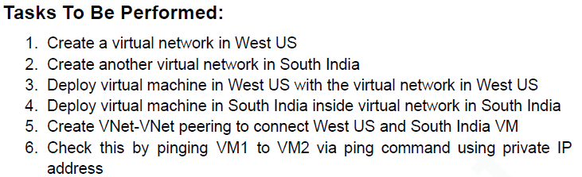

1. Create 2 Resource Group for – westus and southindia.

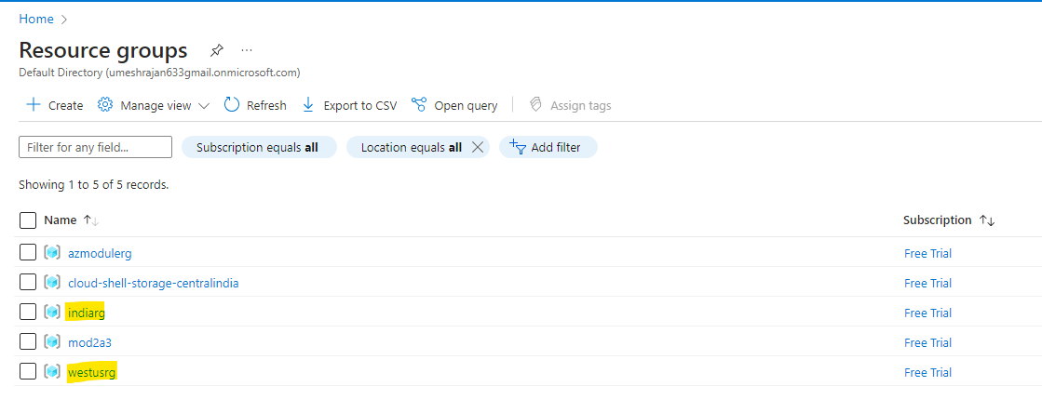

1. Create 2 Virtual Networks of different IP Space.

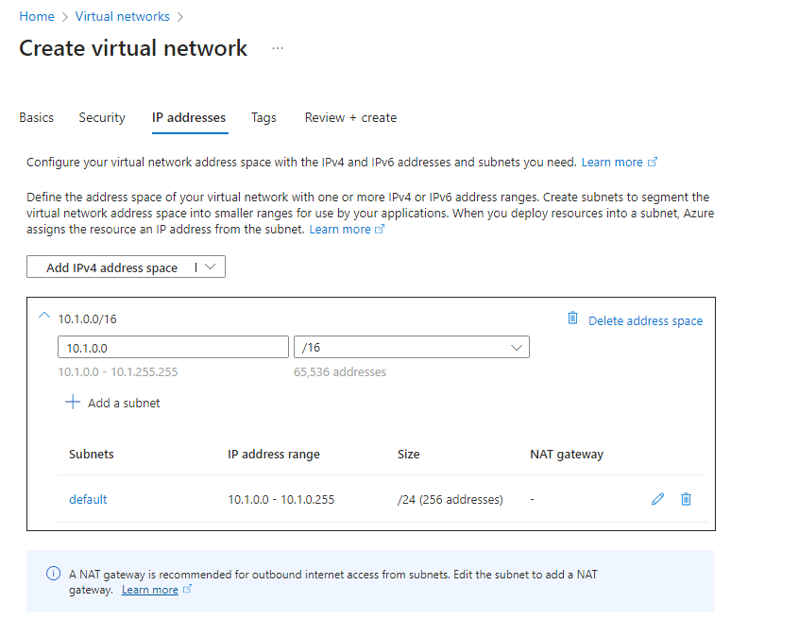

1. Once Virtual Network are created, deploy 2 VM’s. While creating the VM, setup their network to use these newly created Virtual Network.

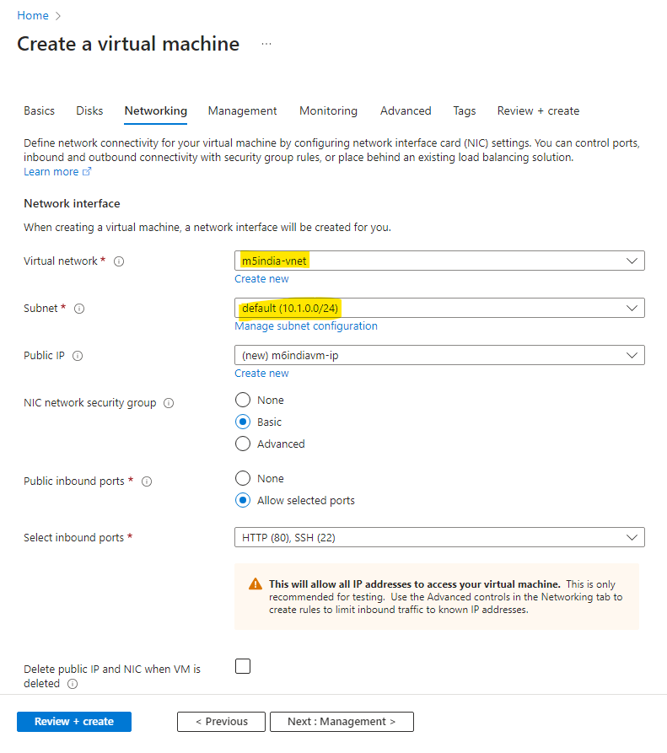

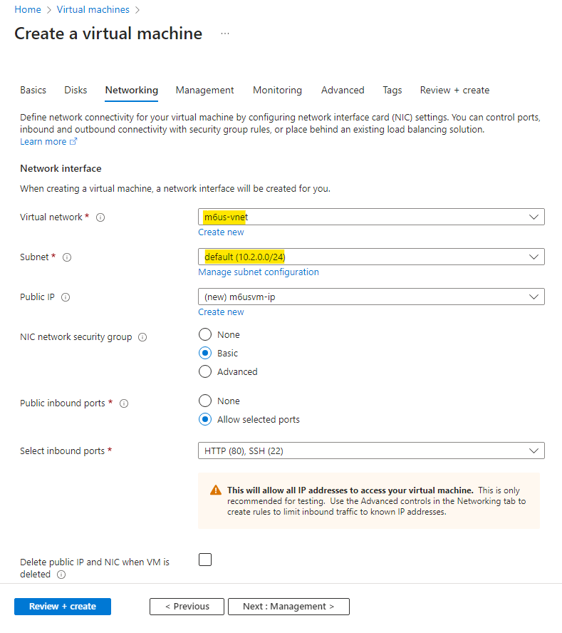

1. Create a Peering between the two Virtual Networks.

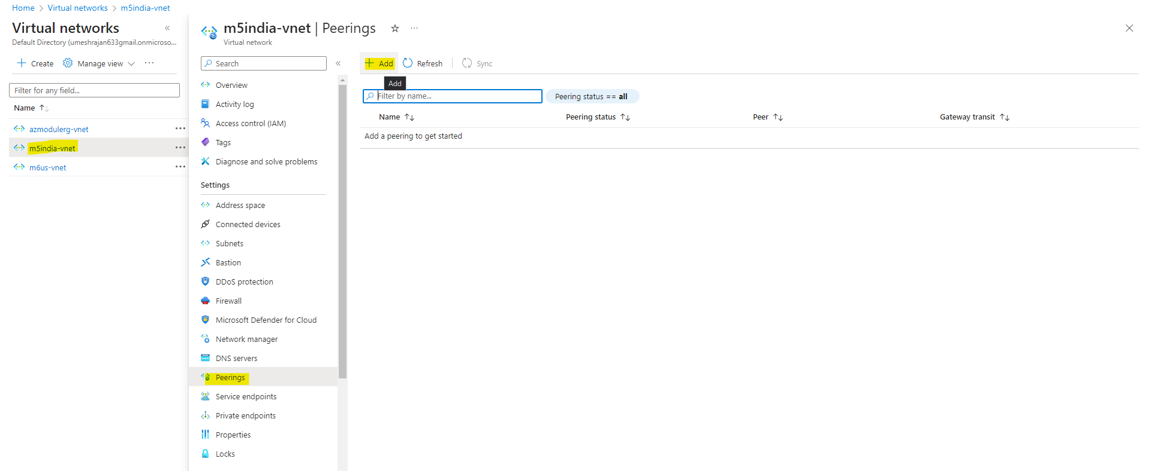

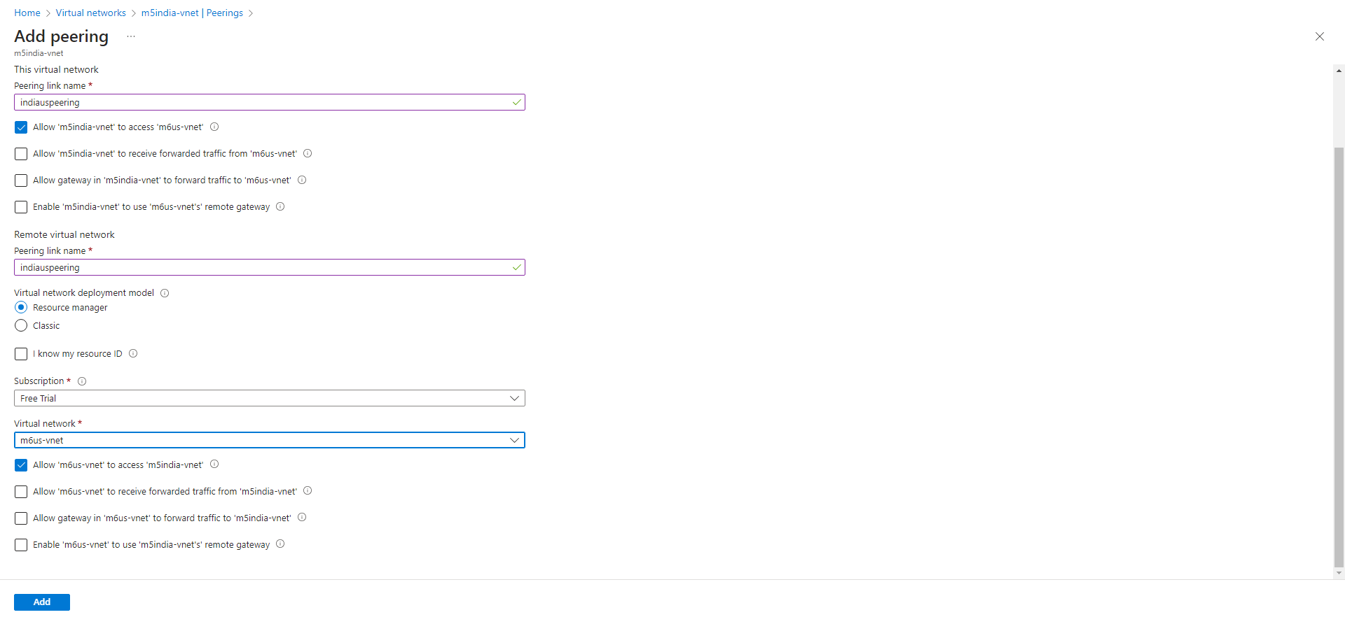

1. Now check the connectivity by pinging the private ip of US region (Connected to India VM).

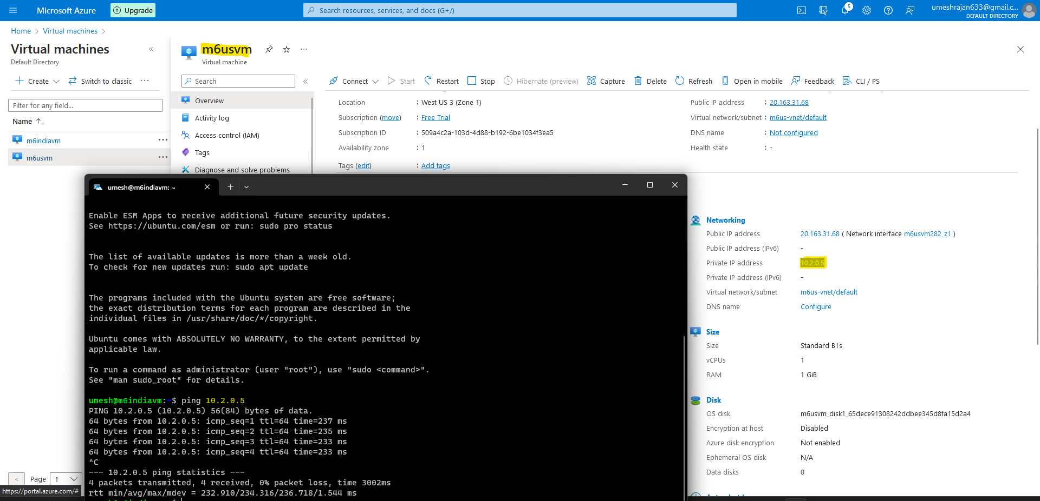

**Assignment 2**

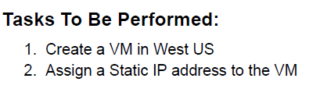

1. Create a new VM, while creating under the Networking Tab. Select Static IP.

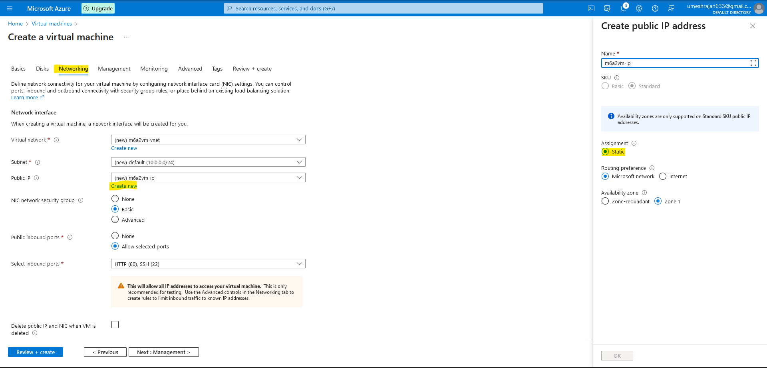

1. Once the VM is created, verify Static IP by stopping and starting the VM.

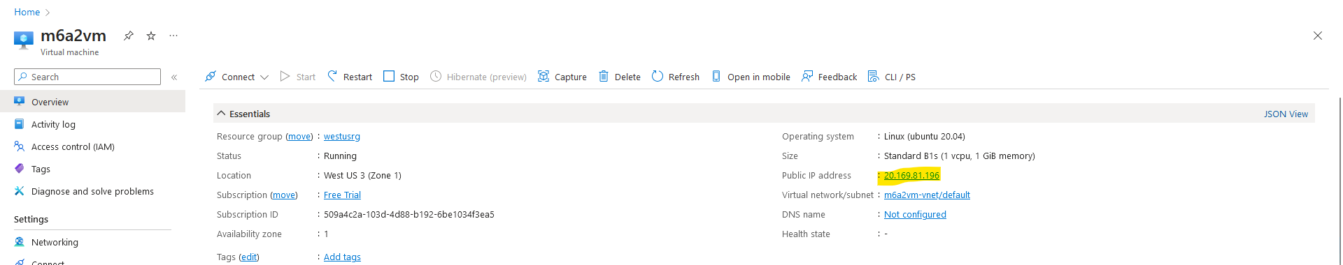

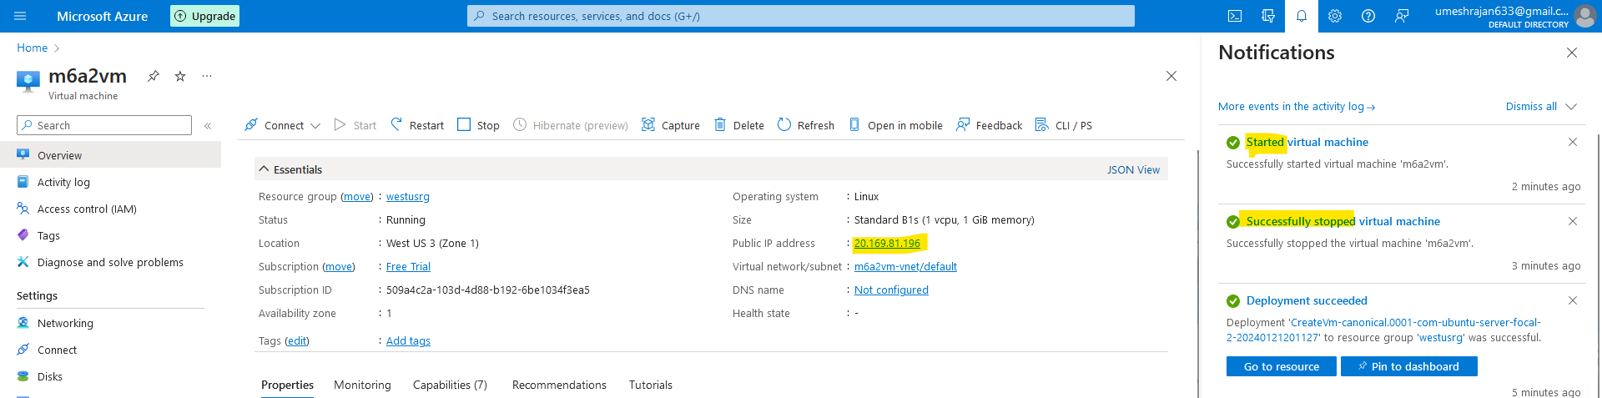

1. As observed, the VM retained it’s public IP.

**Assignment 3**

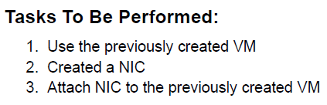

1. Search for Network Interface and Create a new NIC.

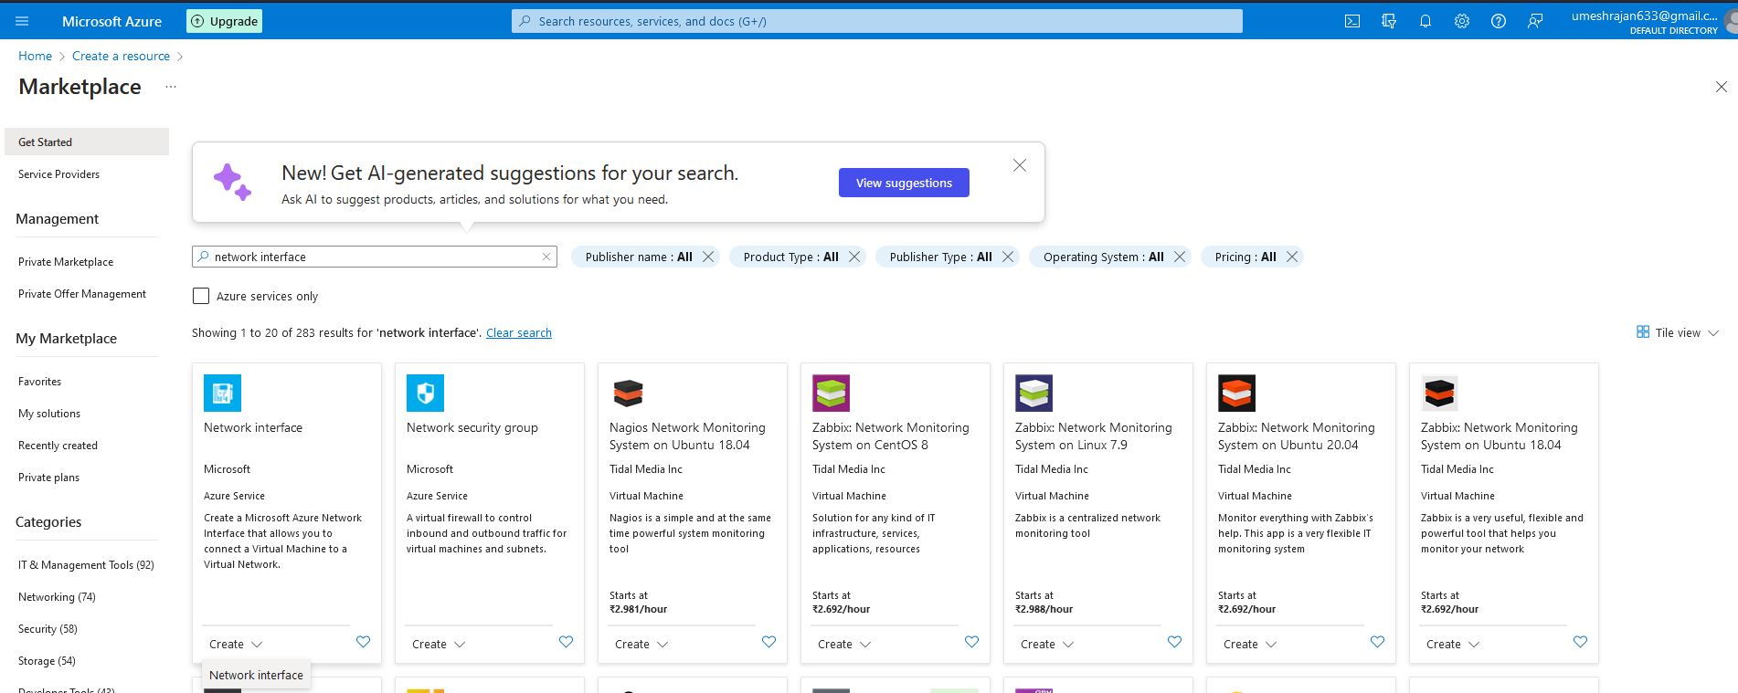

1. Create the NIC.

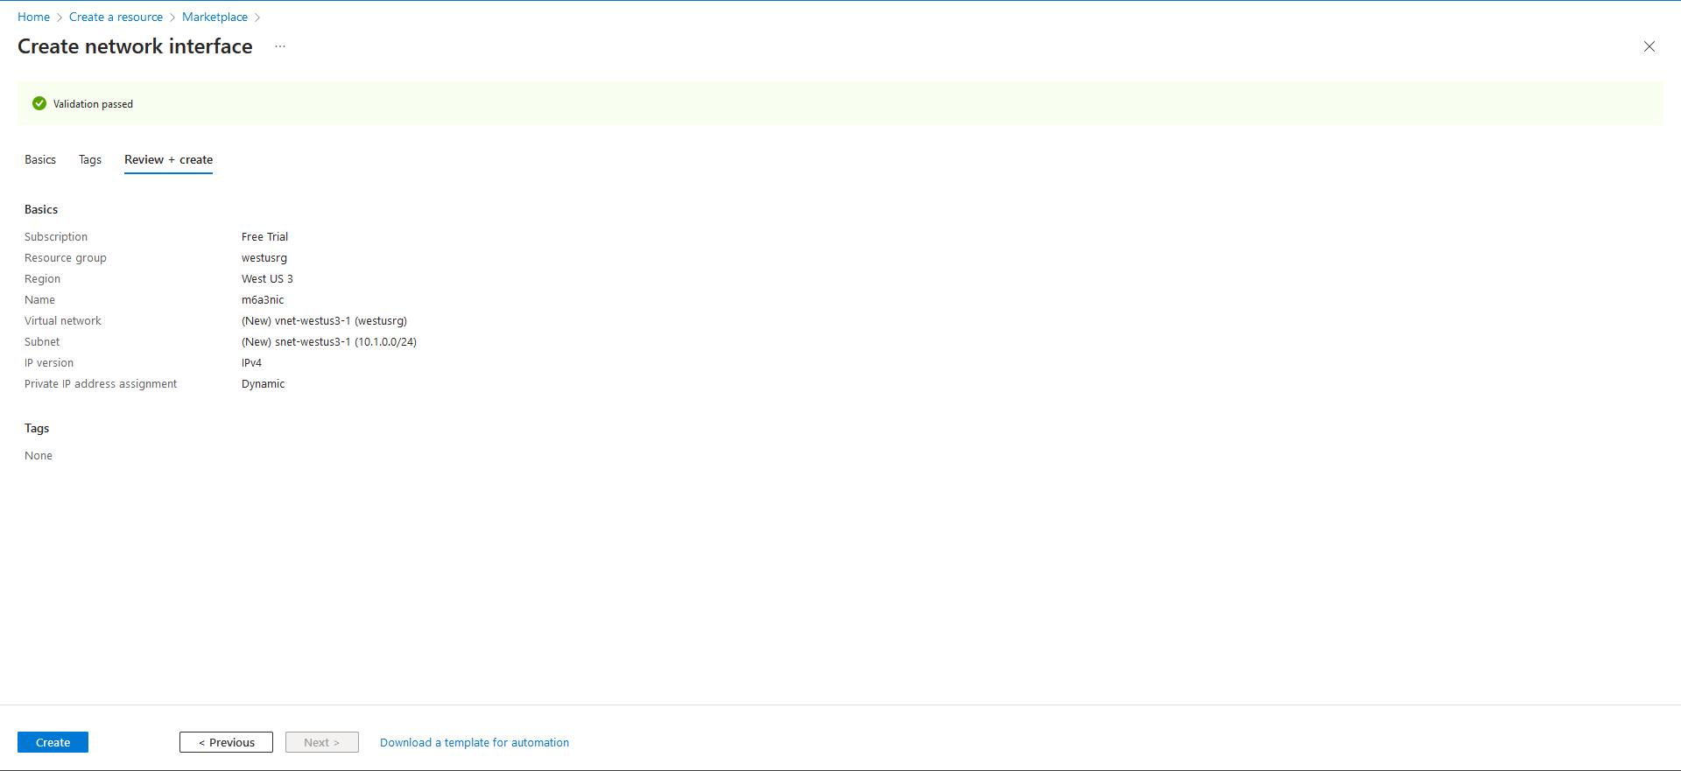

1. Stop the VM and attach the newly created NIC.

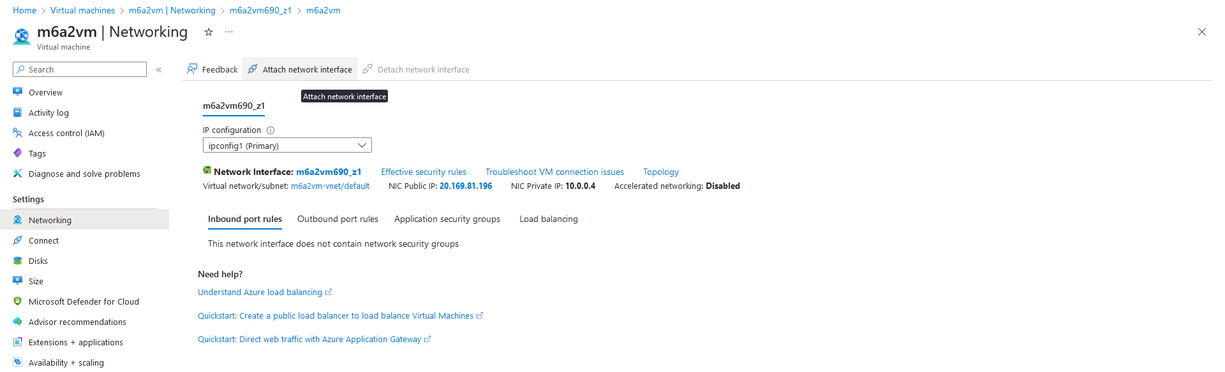

**Assignment 4**

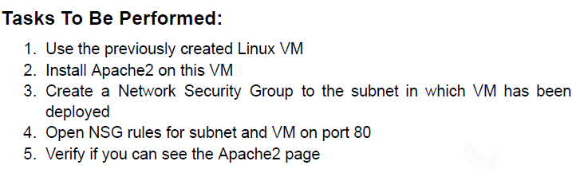

1. Connect to the VM and install apache2 : sudo apt install apache2 -y
2. Create a new Security Group and Add the Inbound Rule for port 80 to allow.

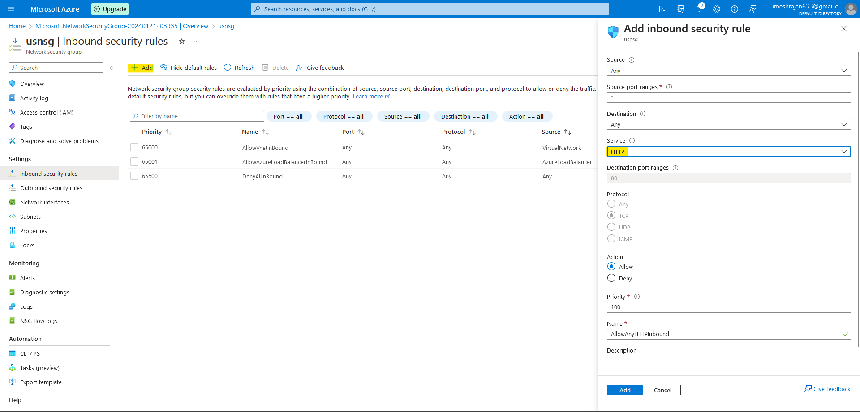

1. Attach the NIC to this Network Security Group.

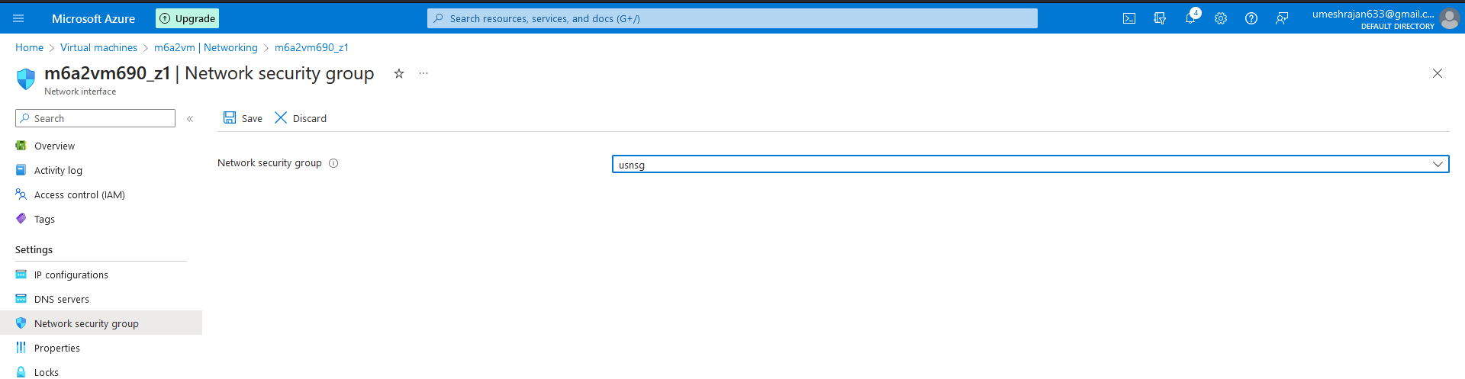

1. Check the Connectivity by accessing the IP.

